Test Report Identifier: TP-12

API version: v2.5

Project: Open Weather Map

Author: Jack Sparrow ([jack-sparrow@openweather.com](mailto:jack-sparrow@openweather.com))

**Test Report**

**Summary:** This document explains the various activities performed as part of testing of OpenWeatherMap API. According to Test Plan ATR-2.6 the list of features was checked: current weather data, 5 day / 3 hour forecast, weather map layer (except satellite base map), API documentation. Postman tool was used for acceptance testing.

**Variances:** Verification of connectivity with the third party system “Vane”’ was not tested, as the connectivity could not be established due to some technical limitations. This can be verified only with real credentials of external system.

Performance testing was not done due to lack of the appropriate environment.

**Comprehensiveness assessment:** Code was covered by unit tests with 100%. Main flows were covered with end to end tests. All Test Cases were executed with the exception of test cases for ‘Weather map layer’ functionality, which were omitted due to not working test credentials to external service 'Vane'.

**Summary of results:** The following is a summary of the test case results obtained for the reported test effort. Test cases for 'Current weather' revealed problems with caching of error response. All found defects were minor. The developers corrected the observed defects and the amended code passed the re-test. However, regressing testing for customer API documentation was not done due to absence of fixes.

|  |  |  |  |  |
| --- | --- | --- | --- | --- |
| **Planned** | **Executed** | **Passed** | **Failed** | **Not tested** |
| 328 | 250 | 247 | 3 | 78 |
| 100 % | 76.20% | 75.3 % | 0.9 % | 23.8 % |

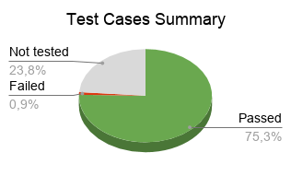 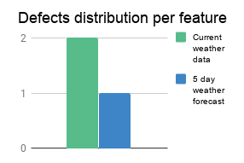

|  |  |
| --- | --- |
| **Bug id** | **Description** |
| OWM-125 | Wrong error message if User tries to get data with different invalid parameters more than once. Response is cached.  **Steps to reproduce:**  **1**. Make Get request with invalid parameter **lat=test** <http://api.openweathermap.org/data/2.5/find?lat=test&lon=4&cnt=2&APPID=76b9fa5e1638d02d4e803e4cb6416528>  **2.** Check response. It should be {"cod":"400","message":"test is not a float"}  **3.** Make Get request with invalid parameter **lat=qwerty** <http://api.openweathermap.org/data/2.5/find?lat=test&lon=4&cnt=2&APPID=76b9fa5e1638d02d4e803e4cb6416528>  **4.** Check response. It should be {"cod":"400","message":"qwerty is not a float"}  **Actual result:** Response is equal to first response {"cod":"400","message":"test is not a float"}  **Expected result**: Response should be equal {"cod":"400","message":"{{value}} is not a float"}, where {{value}} = current value of sent parameter. |
| OWM-126, OWM-128 | Customer API documentation is not fully described. Get parameter ‘lang’ is available for all API methods, but according to document it is available only for methods /find and /group. |

**Evaluation**: As the exit criteria according to Test Plan ATP-2.6 was met and satisfied, this application is suggested to ‘Go Live’ by the Testing team. Appropriate User/Business acceptance testing should be performed before ‘Go Live’.

**Summary of activities**:

*Test Start Date* - May 23th 2018

*Test End Date* - May 30th 2018

**Approvals**:

Project Manager - Tom Brown,

Development Team Manager - Robert Smith.